文獻回顧整理

紅字是重要的文章

Academic Achie Academic Achievement of Childr ement of Children in Single Parent Homes: ACritical Review

General Trend

* a large majority of studies reviewed show that children from single-parent (SP) homes score lower on tests of cognitive functioning and standardized tests, receive lower GPAs, and complete fewer years of school when compared to children from two -parent (TP) homes

Systems perspective

* Krein and Beller (1988) examined differences of the effect of living in a SP home on educational achievement by gender and length of parent absence.
* Mulkey et al. (1992) and Kim (2004) both reported that while family income is important, other factors have a greater influence on academic performance. They suggested that parental expectations, family size, and the quality of the parent-child relationship are stronger predictors of future academic success than income.

Suggestion for future research

* Hetherington et al. (1983) has suggested the possibility that children in SP families initially suffer but then adjust and adapt over time; this process could only be documented with longitudinal research.
* Another area for further study is determining why single parenthood seems to be associated with greater negative outcomes for boys as compared to girls.

\* 屬於文獻回顧型的文章。

Amato, P. R., Patterson, S., & Beattie, B. (2015). Single-parent households and children’s educational achievement: A state-level analysis. *Social science research*, *53*, 191-202.

Abstract

* Although many studies have examined associations between family structure and children’s educational achievement at the individual level, few studies have considered how the increase in single-parent households may have affected children’s educational achievement at the population level. 這篇文章主要 focus州立的單親比率增加對小孩成績的影響
* We examined changes in the percentage of children living with single parents between 1990 and 2011 and state mathematics and reading scores on the National Assessment of Educational Progress.
* Regression models with state and year fixed effects revealed that changes in the percentage of children living with single parents were not associated with test scores.

本篇主要是證明單親家庭總體上是否有負面的社會成本，過去文獻證明個體層次上，單親家庭確實對個體有負面影響，但總體而言，單親家庭的比例增加，並不會造成整體學習成績的負面效應。

Pong, S. L. (1998). The school compositional effect of single parenthood on 10th-grade achievement. *Sociology of education*, 23-42.

Abstract

* Using NELS data, the author also found a detrimental contextual effect on 10th-grade mathematics and reading achievement associated with attending a school in which a high concentration of children are from single-parent homes. This effect was evident even when individual demographic characteristics and family background were controlled.

控制其他家庭所得變數後，單親母親家庭對學生數學、閱讀成績並沒有顯著負面影響，但單親父親有。另外，父母重視學歷有很強的正向效果。

太早期的文章好像沒啥參考性。

Pong, S. L., Dronkers, J., & Hampden‐Thompson, G. (2003). Family policies and children's school achievement in single‐versus two‐parent families. *Journal of marriage and family*, *65*(3), 681-699.

Abtract

* We investigate the gap in math and science achievement of third- and fourth-graders who live with a single parent versus those who live with two parents in 11 countries.
* The United States and New Zealand rank last among the countries we compare in terms of the equality of achievement between children from single-parent families and those from two-parent homes.
* the single- and two-parent achievement gap is greater in countries where single-parent families are more prevalent. We conclude that national family policies can offset the negative academic outcomes of single parenthood.

Results

* Single parenthood is associated with lower math and science achievement among young children in all 11 countries except Austria and Iceland.
* We did find, from our multilevel analysis, that the achievement gap between single- and two-parent families is narrowed where there are family policies aimed at equalizing economic resources between single-parent and other families.

本篇作者將不同國家的影響歸因於國家的家庭政策，澳洲、冰島因為有較完善的平等家庭政策，使離婚對小孩的數學與科學成績負面影響較小。

Bernardi, F., & Radl, J. (2014). The long-term consequences of parental divorce for children’s educational attainment. *Demographic research*, *30*, 1653-1680.

Abstract

* Across the 14 countries considered in this study, children of separated parents have a probability of achieving a university degree that is on average seven percentage points lower than that of children from intact families.
* The breakup penalty is stronger for children of highly educated parents, and is independent of the degree of diffusion of divorce.
* In countries with early selection into educational tracks, divorce appears to have more negative consequences for the children of poorly educated mothers.

Some concern

* our findings indicated that when the level of stratification in an educational system is low, parental divorce tends to reduce inequality of educational opportunities.
* we did not have sufficient data to control for further differences between children of divorced parents and children from intact families, which may induce selection effects.
* Divorcing parents with high and low levels of education might therefore differ in terms of unobserved factors that could affect the children's educational attainment. If, for instance, highly educated parents are less likely to divorce and do so only when there is a very high degree of conflict in the relationship, then their children might be selected on negative unobserved characteristics that might also explain their larger penalty in educational attainment. 高教育父母離婚對小孩的影響更大，可能是因為高教育父母的離婚與低教育程度的父母有本質上的差異，導致其效果更大。但沒有資料可以佐證這個假設。

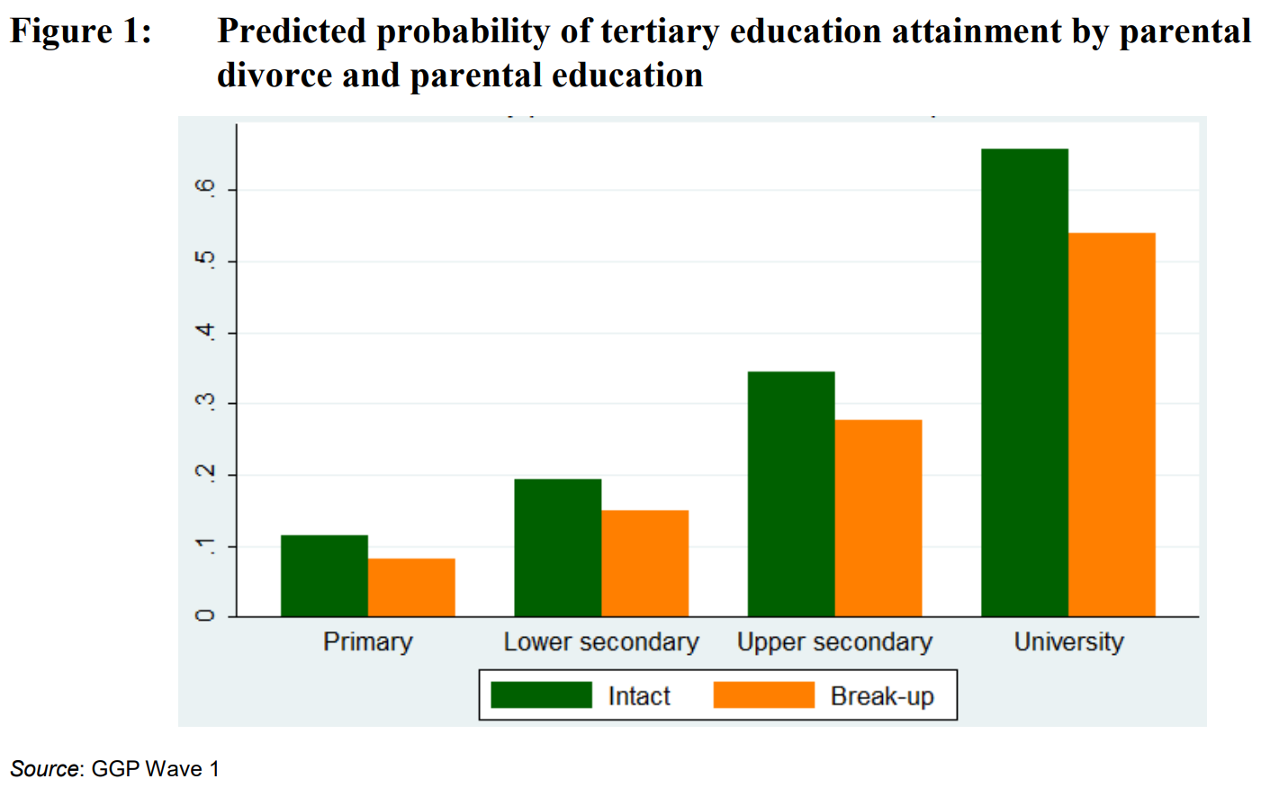

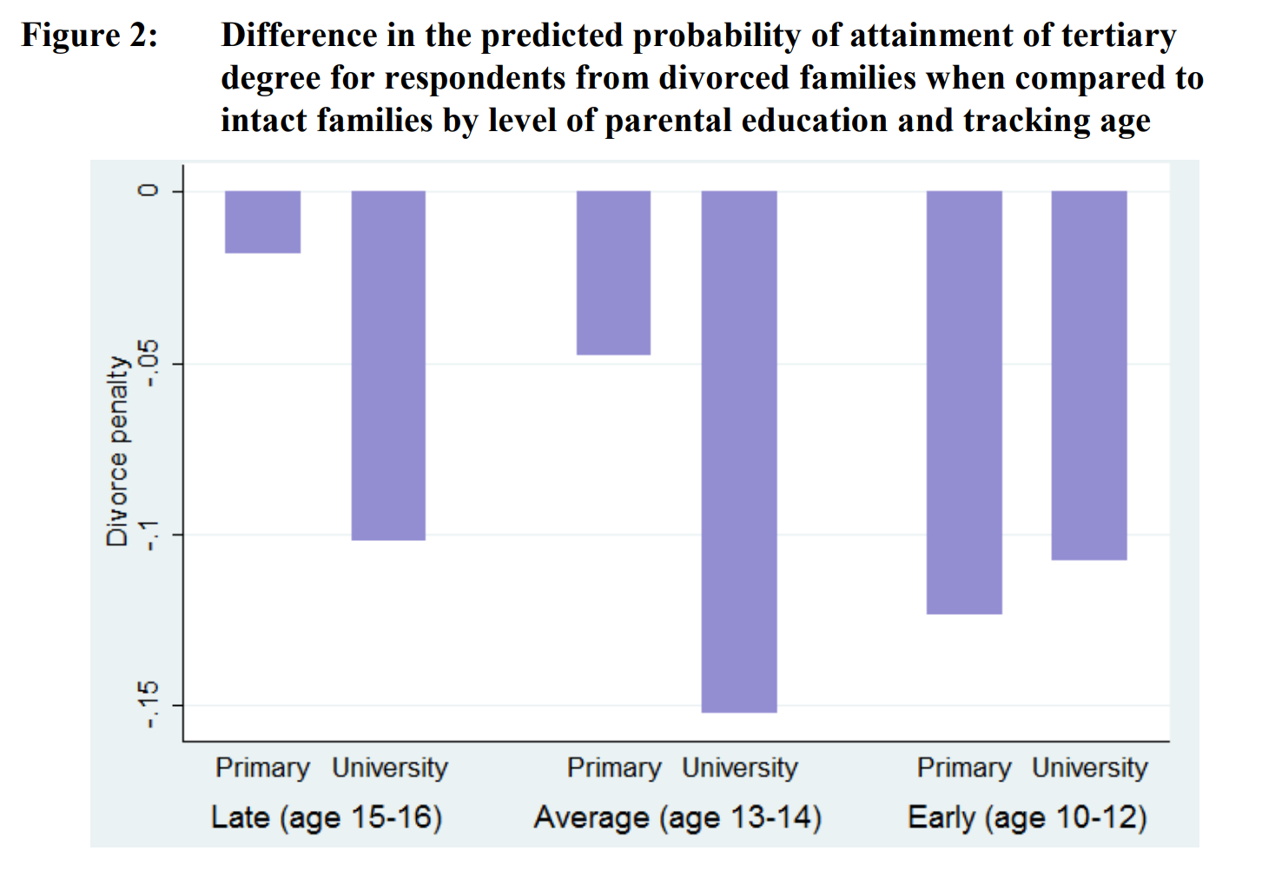

\* 這篇參考性很高，可當作範本